Designing and Building an Interactive Dashboard - Submission
This template helps you capture and share screenshots of your code and results for each task.

Instructions
- Insert answers to relevant questions or screenshots showing the relevant KPI scorecard, charts, or dashboard, as mentioned in the tasks of the project.
- Ensure all screenshots are readable.
- You can share the screenshots in any of the following formats: .png, .jpg, .jpeg, .jfif, .webp, .bmp, .tiff, .tif

Part 1, Healthcare analytics and visualization
Task | Activity name | Screenshot of both the code and output
1 | Key Performance Indicators (KPIs)  Add the following KPI scores:  - Total number of patients served  - Total revenue generated  - Average patient satisfaction score  - 30-day hospital readmission rate | <Paste the screenshot depicting all four KPI scores>  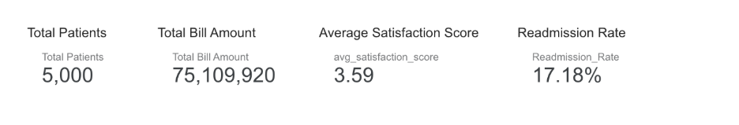
2 | Analyze visit types  Create a bar chart to display visit counts by visit type. | <Paste the screenshot of the chart>  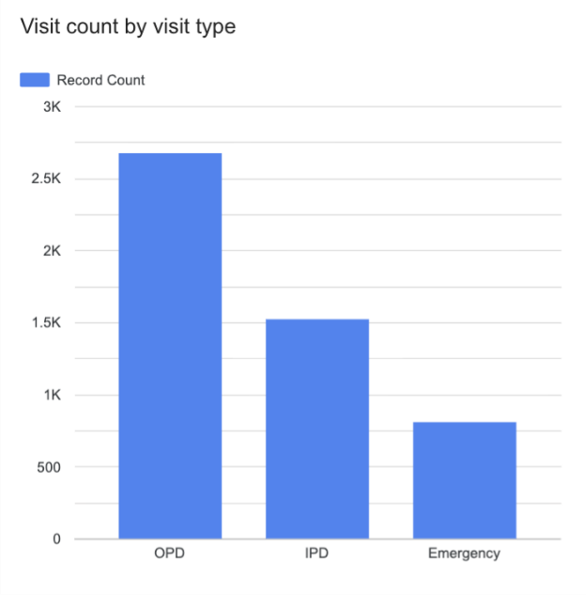
3 | Financial performance by hospital  Create a bar chart that displays total revenue (total bill amount) by hospital. | <Paste the screenshot of the chart>  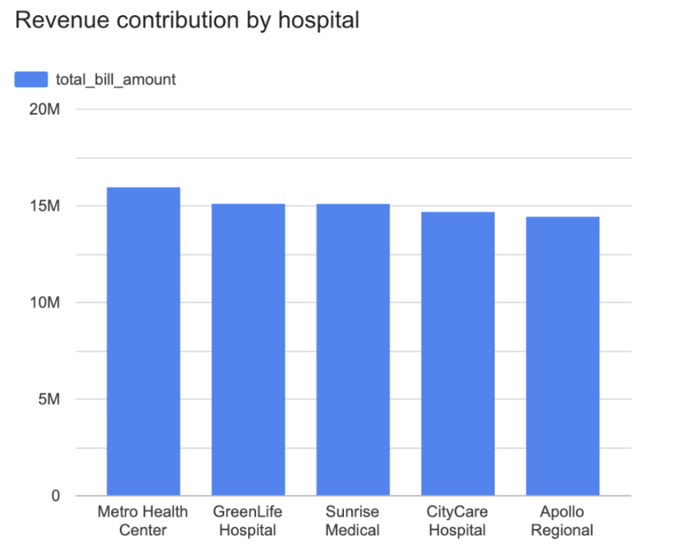
4 | Total hospital revenue with insurance type breakup  Create a stacked bar chart depicting the total bill amount by hospital name and insurance type. | <Paste the screenshot of the chart>  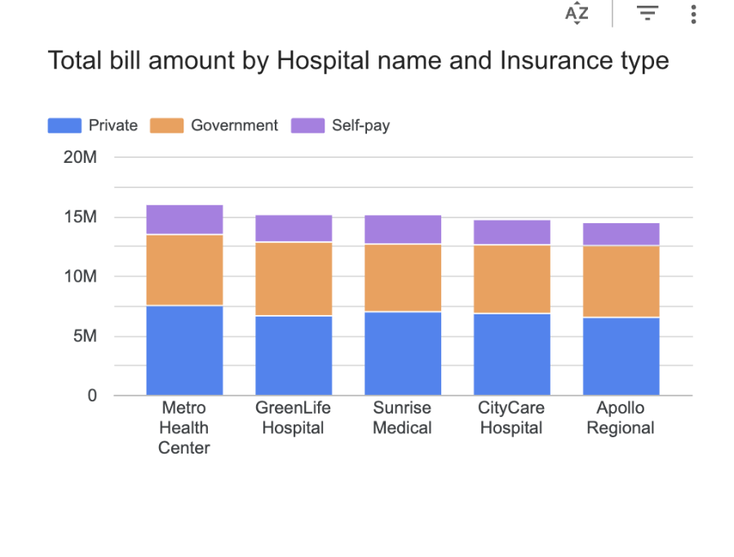
5. | Revenue impact of visit type by hospital  Create a stacked bar chart that highlights the revenue generated by each hospital, segmented by visit type. | <Paste the screenshot of the chart>  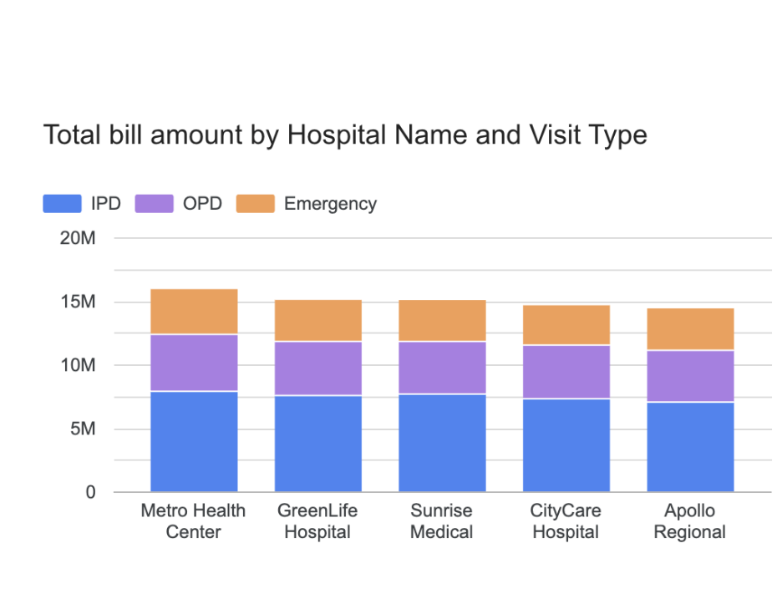
6. | Geospatial healthcare access analysis  Create a map using latitude and longitude to represent hospital locations and encode patient volume using marker size or intensity. | <Paste the screenshot of the chart>  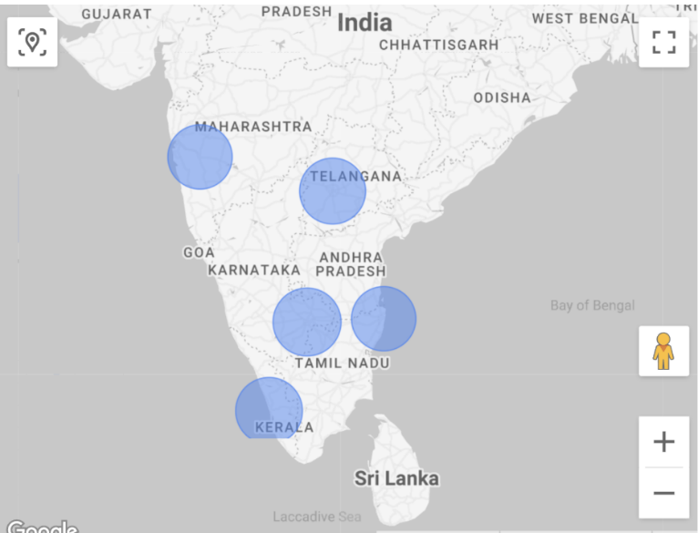
7. | Insurance and payment analysis  Create a pie chart that displays cost distribution across insurance types. | <Paste the screenshot of the chart>  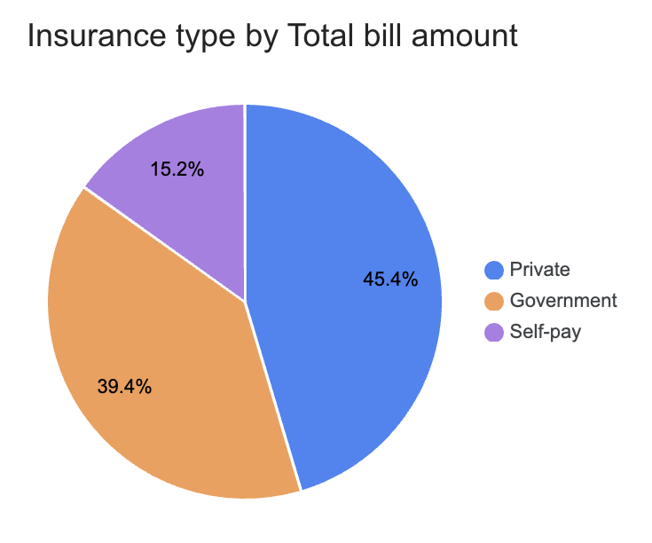
8. | Readmission risk insights  Create a line chart that highlights readmission patterns across key variables, including visit type, length of stay, chronic conditions, and patient satisfaction. | <Paste the screenshot of the chart>

Part 2: Executive healthcare dashboard design
1 | Using the provided Regional Healthcare dataset and the KPI scorecards and charts created in Part 1, create a simple executive summary dashboard considering the design requirements mentioned in Part 2. | <Paste the screenshot of the dashboard>
2 | Write 1–2 sentences explaining how the dashboard layout supports executive decision-making. | <Write the answer here>

